CARS ARENA

Online Car store is named as Car Arena built using HTML, CSS and JavaScript.

**Tools Used:**

HTML

CSS

JavaScript

**Screenshots:**

Home Screen -

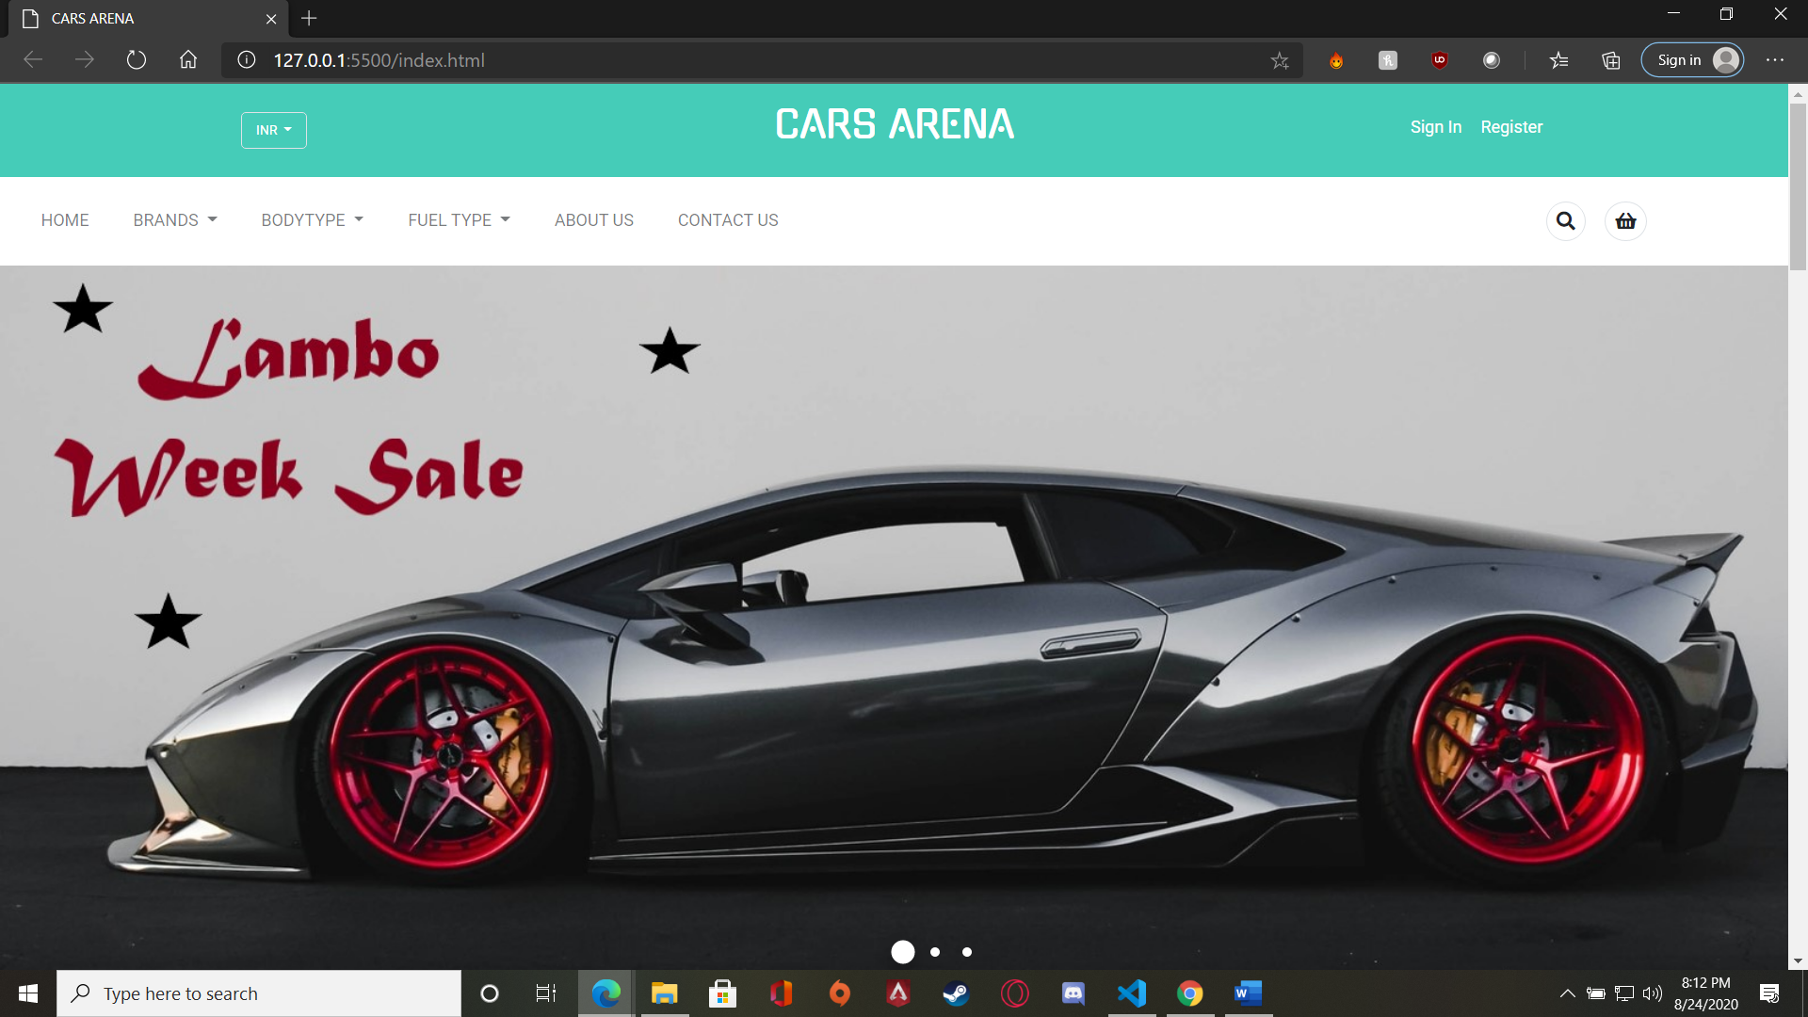

Featured Models -

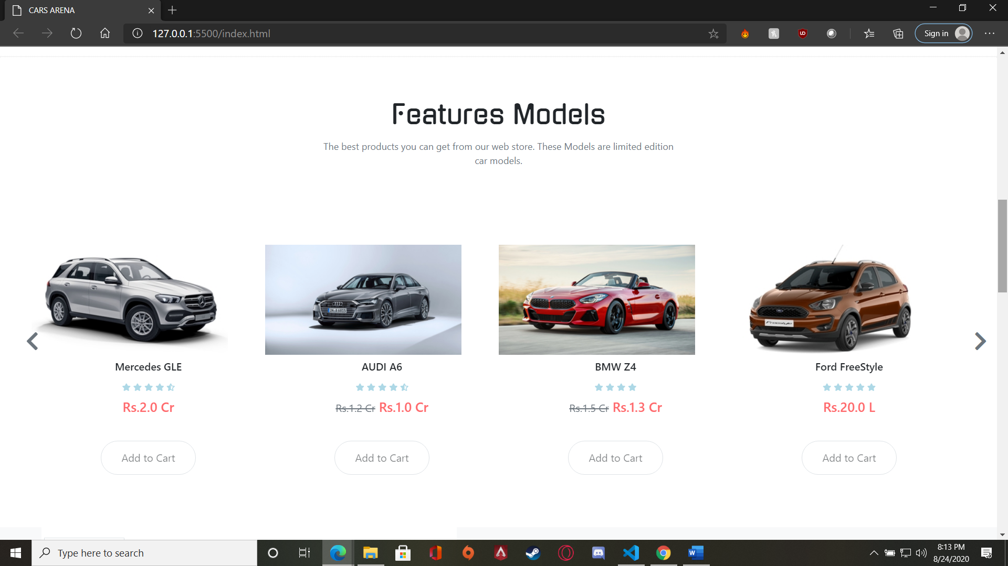

Limited Time Section –

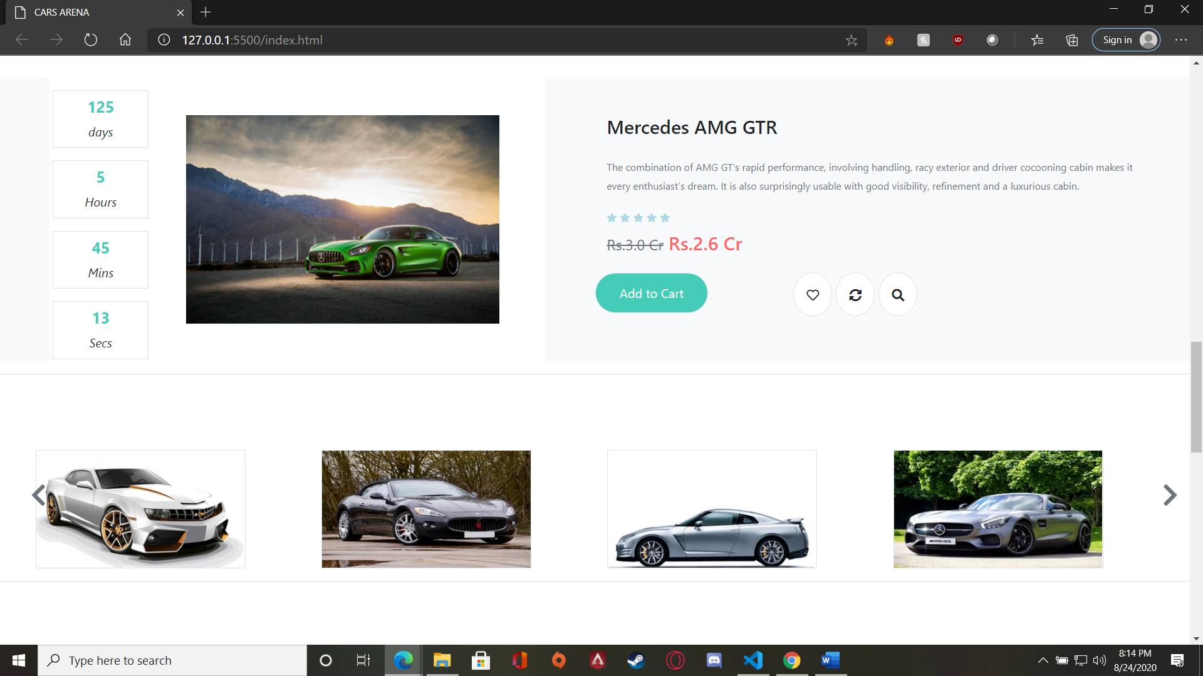

Brands and Popular section –

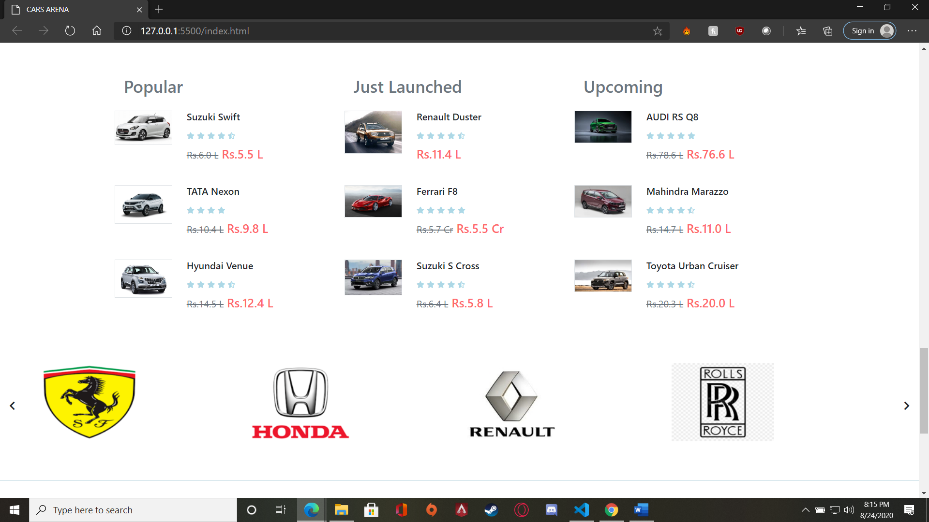

Footer section –

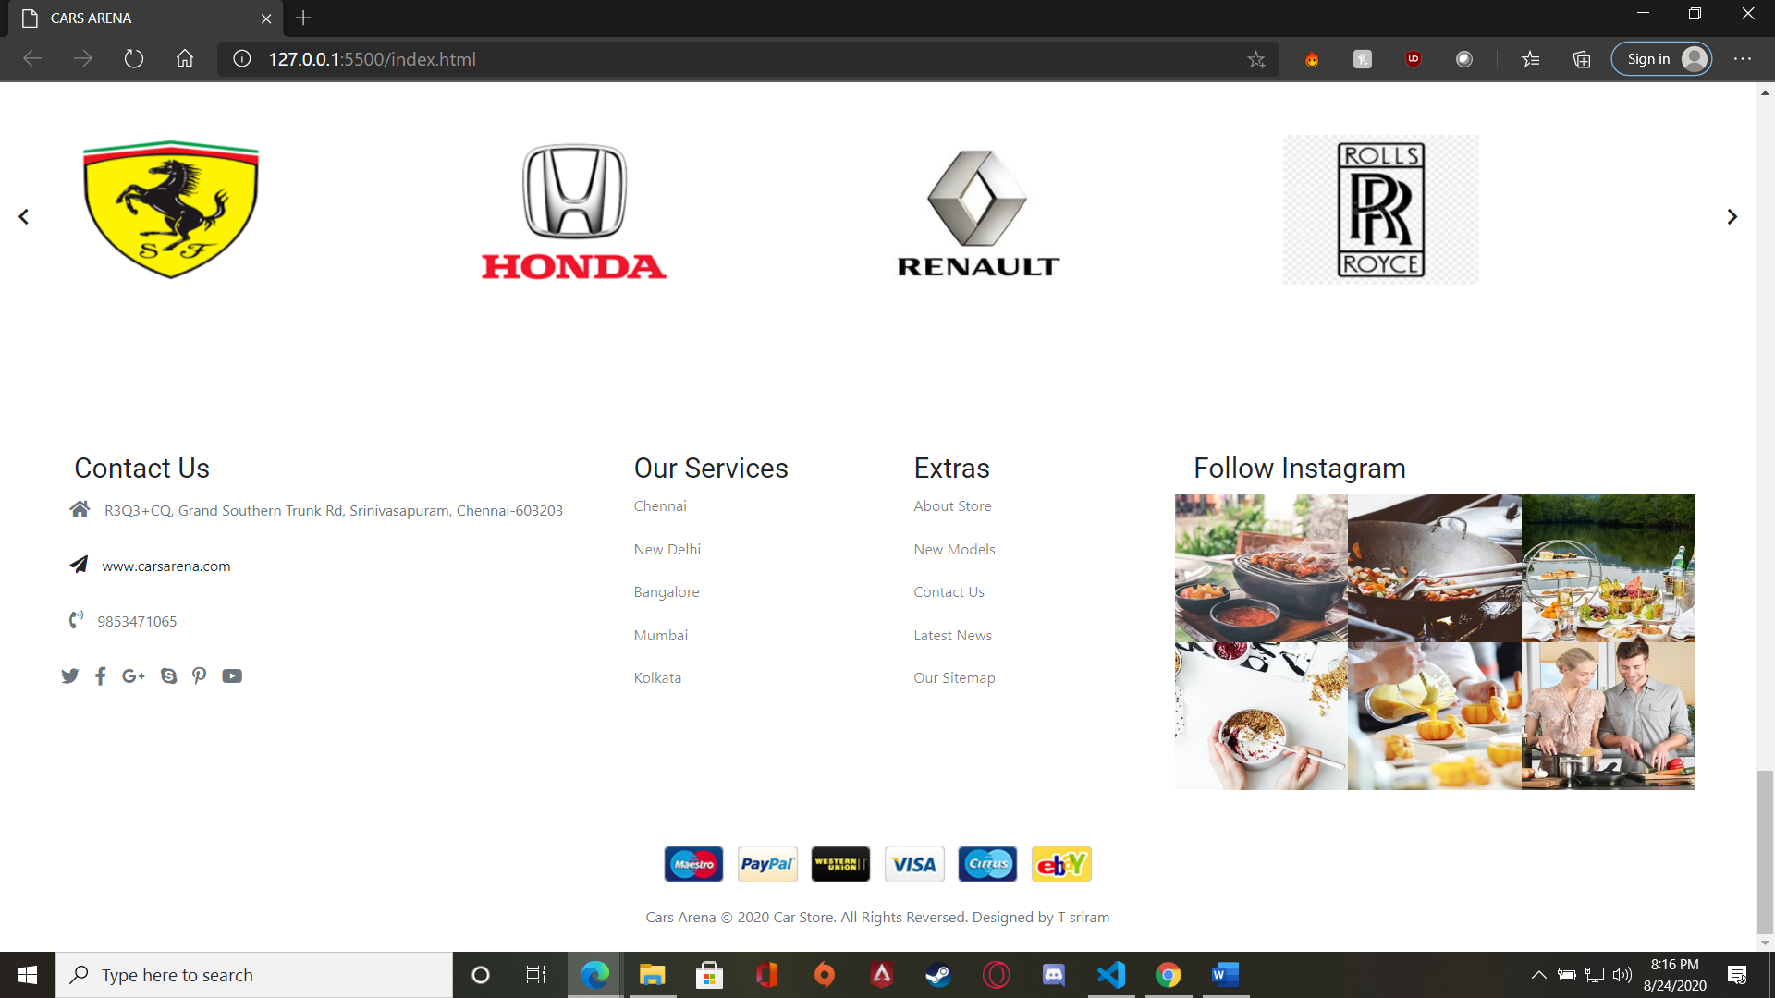

Product Section – Hatchback

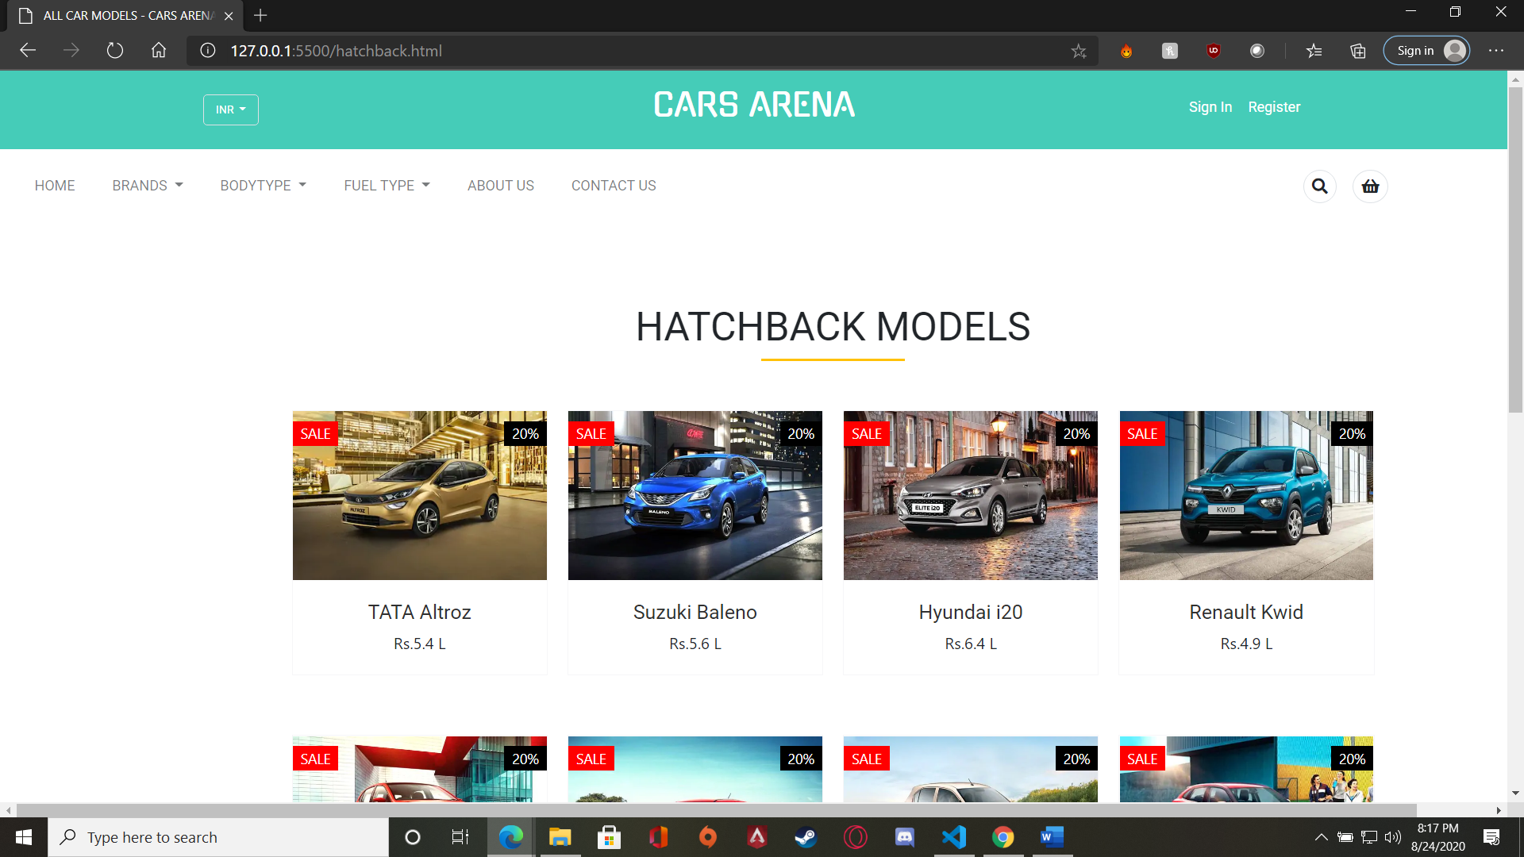

Product Section – Sedan

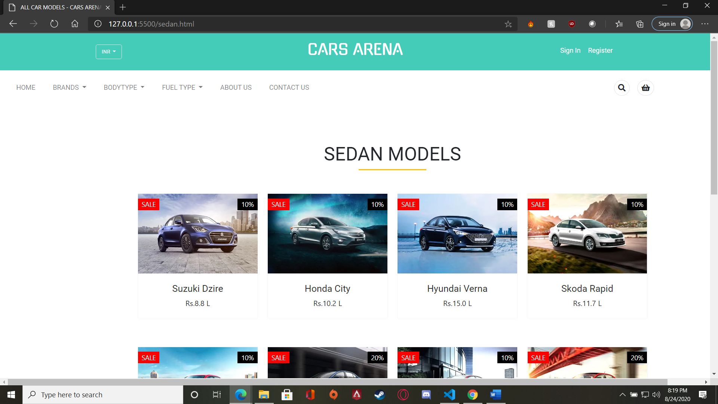

Login and Register Page –

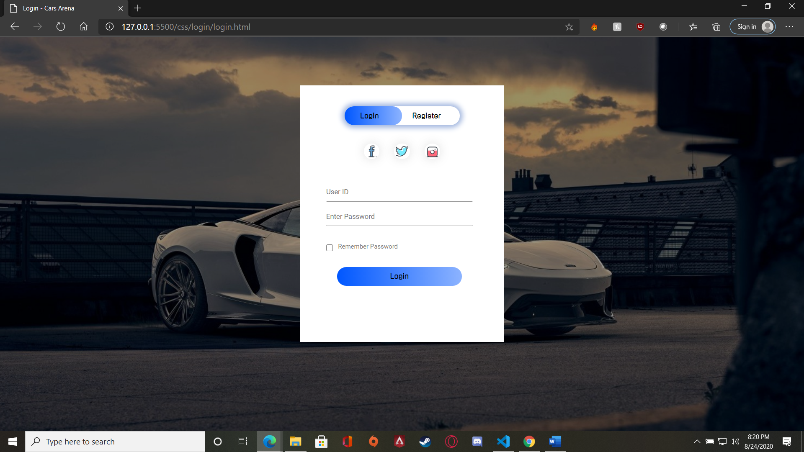

Done by:-

T SRIRAMASIVAM

RA1711020010057